|  |  |
| --- | --- |
|  |  |
|  | Text Analytics  with R and Azure Machine Learning |

Contents

Overview 3

Create a New Experiment 5

Read in External Data 8

Use R Scripts in the Experiment 11

Terms of Use 30

|  |
| --- |
| Overview |

### Summary

This lab explores text analytics and R integration with Azure Machine Learning.

It will walk through loading data from an external source, using R scripts in ML Studio, and common text analytics tasks and visualizations.

### Business Case

Social media has become a very influential platform for companies, consumers, and professionals to express ideas and opinions, market new products and advertise sales, or share any other important news and information. Most social media sites include keywords or hashtags users can post related content to. If companies can access and perform advanced analytics on the keyword posts that are relevant to them, they can learn things such as customer sentiment, related products and companies, and who is buying products and where from.

For this lab, you will be working with real Twitter data pulled from a Twitter API. The data includes real Tweets that used the hashtag, Azure

The R language has an expansive collection of packages and functions for advanced text mining and analytics. The lab will use R scripts that will be executed in ML Studio. These scripts will perform data preparation, exploration, and visualization tasks common to text mining. The end result will be a visualization that provides context to frequently used terms in the analyzed Tweets.

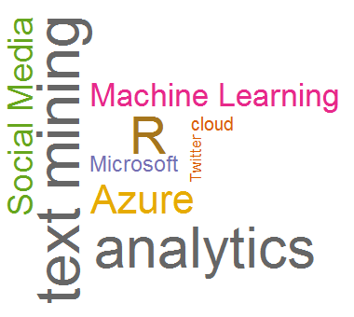

### Learning Objectives

Upon completing this lab, you will have hands-on experience with the following functions and concepts related to Azure Machine Learning and R:

* Reading data from Azure Blob Storage into an experiment in ML Studio
* Executing R Scripts in ML Studio
  + Connecting input data to R Scripts in ML Studio
  + Visualizing data outputs from an R Script in ML Studio
  + Visualizing charts and graphs from an R Script in ML Studio
* Performing common text analytics tasks in R
  + Preparing/Cleaning unstructured text data
  + Aggregating/extracting terms from unstructured data
  + Visualizing term frequency with a Word Cloud

### Lab Requirements/Prerequisites

* A Microsoft account is required to access an Azure Machine Learning workspace. If you don’t already have a Microsoft account, you can obtain one for free by following the link below:

<https://www.microsoft.com/en-us/account/default.aspx>

|  |
| --- |
| Create a New Experiment |

### Create/Access an Azure Machine Learning Workspace

To get started, you will need to create and log in to a free Azure Machine Learning workspace. A workspace is like an all-inclusive development environment with the tools to create, manage, and publish machine learning models.

1. Open Internet Explorer using the shortcut on the desktop taskbar.
2. Go to the ML Studio website by typing <http://studio.azureml.net> in the address bar.
3. Click Sign In on the top right corner of the web page.

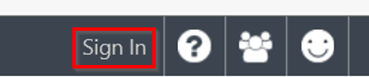

1. Enter the email address and password associated with your Microsoft ID, and click the Sign In button.

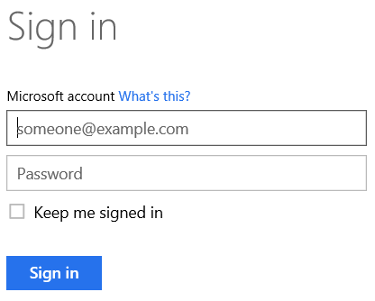

1. If upon logging in, a Welcome video is displayed (usually displays on the first login), click the X at the top right of the video to close it.

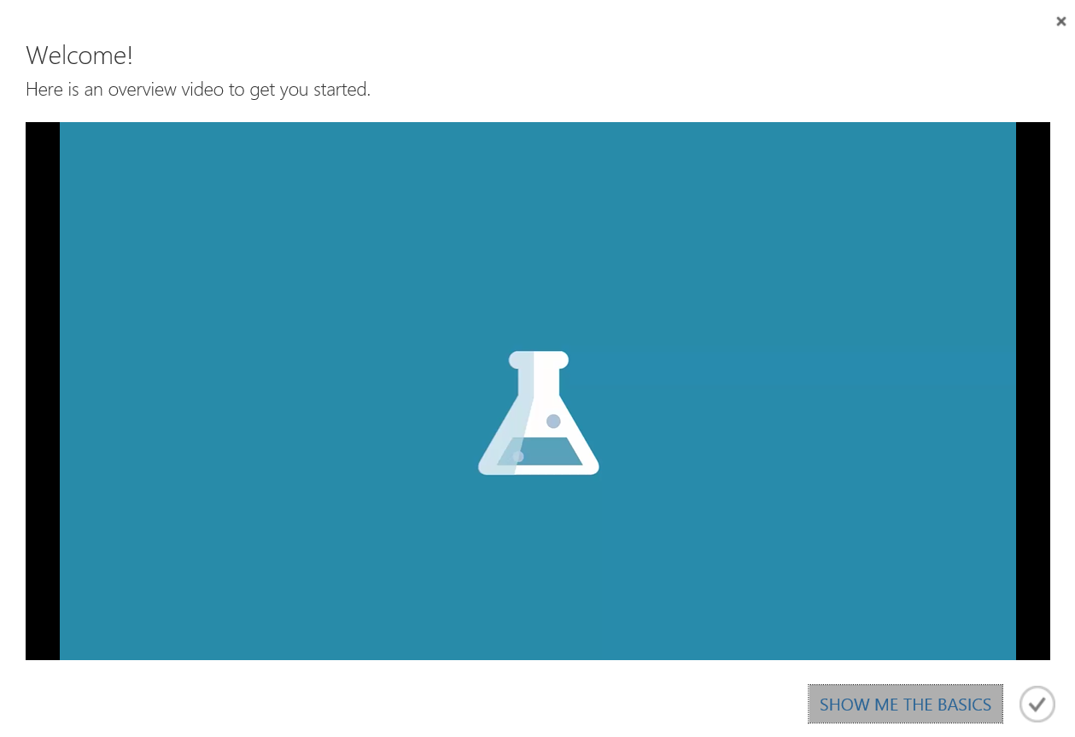

1. If the Microsoft Samples dialogue box is displayed (usually displays on the first login), go ahead and close it by choosing the X in the top right corner of the pane.

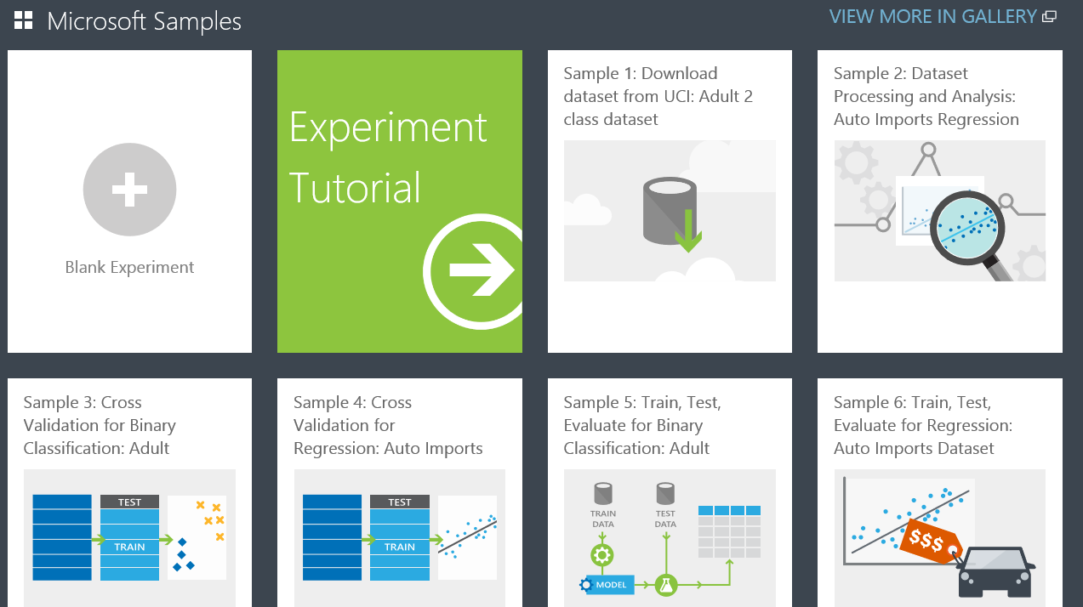

You are now logged into the free workspace associated with your Microsoft ID.

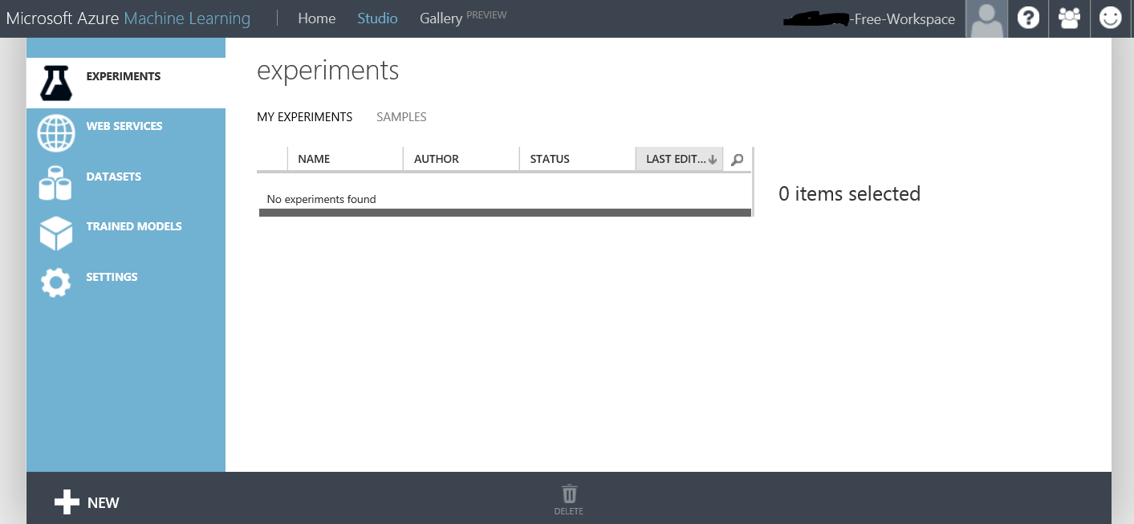

### Create a Blank Experiment

Next, we will create our first experiment. An experiment is a collection of data, tasks, and machine learning algorithms that make up a model.

1. Click the NEW button in the bottom left corner of the page.



1. Make sure EXPERIMENT is highlighted in the NEW dialogue window, and click the Blank Experiment pane.

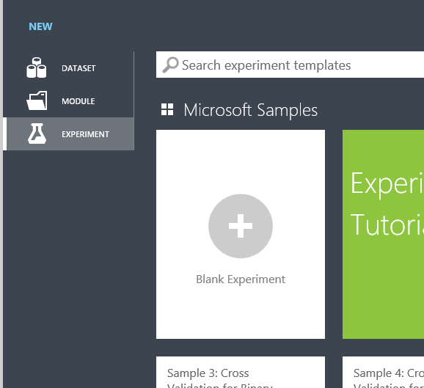

1. At the top of the canvas, highlight and delete the text that reads Experiment created on…, and replace it with Lab – Text Mining with R.

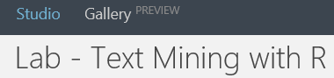

|  |
| --- |
| Read in External Data |

### Get Data from Azure Blob Storage

The data you will use in this lab is stored in Azure Blob storage. The next series of steps will pull this data into ML Studio so you can work with it.

1. In the modules pane click and expand Data Input and Output.

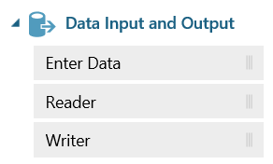

1. Click and drag the Reader module onto the canvas.

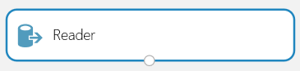

Notice the parameters in the Properties pane for the Reader module. We will modify these to pull a specific Blob from Azure Blob Storage.

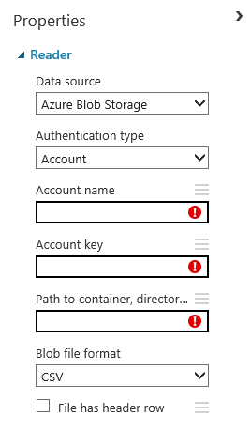

1. Enter/Change the following values in the Properties pane for the Reader module:

Data source: Azure Blob Storage

Authentication type: PublicOrSAS

URI: http://bgmslabs.blob.core.windows.net/machinelearning/tweetsdataset.csv

File format: CSV

Check the URI has header row checkbox.

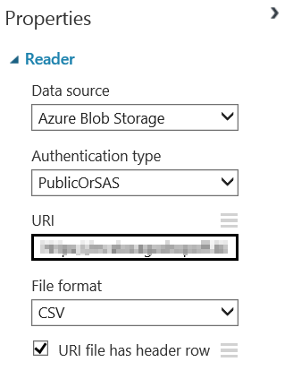

1. Click RUN at the bottom of the canvas to execute the experiment and read in the data from Azure Blob Storage.



1. Once the experiment finishes running, click the output port on the Reader module, and select Visualize on the displayed menu.

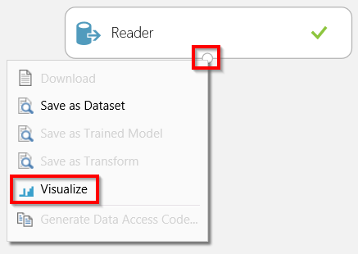

The input data includes 106 rows. Each row includes a Twitter username and the text from a Tweet the user Tweeted.

1. Click the X in the top right corner of the Visualize dialogue box to close it.
2. Click SAVE to save the experiment.



|  |
| --- |
| Use R Scripts in the Experiment |

### The Execute R Script Module

Next, you will begin working with the Execute R Script module in ML Studio. The Execute R Script module allows custom R scripts to be executed in the experiment.

1. In the Modules pane, click and expand R Language Modules.

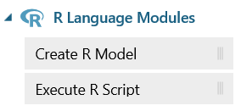

1. Click and drag the Execute R Script module onto the canvas under the Reader module.

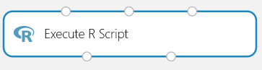

1. Connect the output port from the Reader module to the first input port on the Execute R Script module.

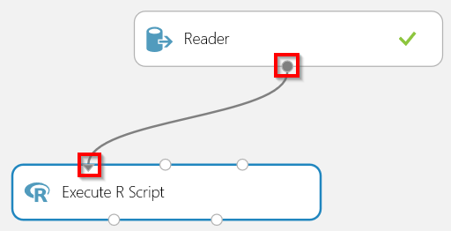

Notice the R Script editor in the Properties pane.

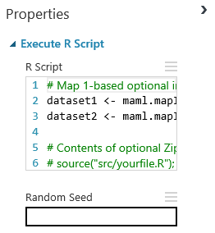

1. Click anywhere in the R Script editor.

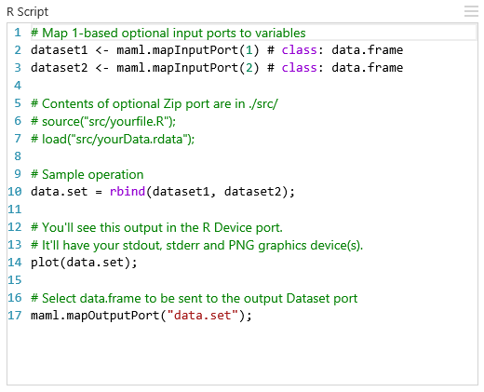

You can delete and edit any and all parts of the default R script.

Notice a few important elements of the default script:

1. The first 2 lines of code map the first and second input ports of the Execute R Script module to data frame objects.



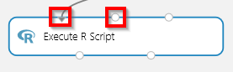

1. Line 14 uses the plot function. Any graph, chart, or other visualization created in your script will automatically output to the right output port of the Execute R Script module.



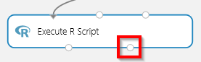

1. The final line of code maps a data frame object to the left output port of the Execute R Script module.



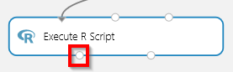

1. Use the mouse to select all the code in the R Script editor and hit the Delete key on the keyboard.

library(dplyr)

library(ggplot2)

#set input data to object

Tweets<-as.data.frame(maml.mapInputPort(1))

#summarize Tweets

summaryOfTweets <- group_by(Tweets, user) %>% summarise(numberOfTweets = n()) %>% arrange(desc(numberOfTweets))

top5<-as.data.frame(head(summaryOfTweets, n = 5))

#visualize summary with bar chart

ggplot(top5, aes(x = reorder(user, numberOfTweets), y = numberOfTweets, width = 0.5)) +

geom_bar(stat = "identity", fill = "grey70", colour = "black") +

coord_flip() +

ggtitle("Top users Tweeting with the keyword Azure") +

xlab("Username") +

ylab("Number of Tweets")

#output data

maml.mapOutputPort("top5")

1. Copy and paste the code below into the R Script editor:
2. Click RUN at the bottom of the canvas to execute the experiment with the R script.

This script loads the Tweets data from the left input port, summarizes the Tweets by user, and then creates a bar chart of the output.

1. Once the experiment has finished executing, click the left output port on the Execute R Script module and select Visualize from the displayed menu.

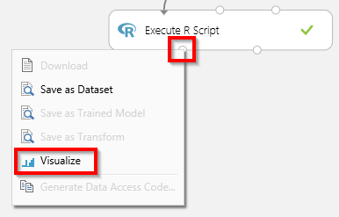

Notice the top 5 Twitter accounts by number of Tweets from our dataset.

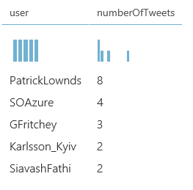

1. Click the X in the top right corner of the Visualize dialogue box to close it.
2. Click the right output port on the Execute R Script module and select Visualize from the displayed menu.

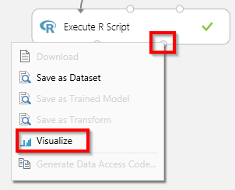

Notice the bar chart that the R script created showing the top 5 users by number of Tweets.

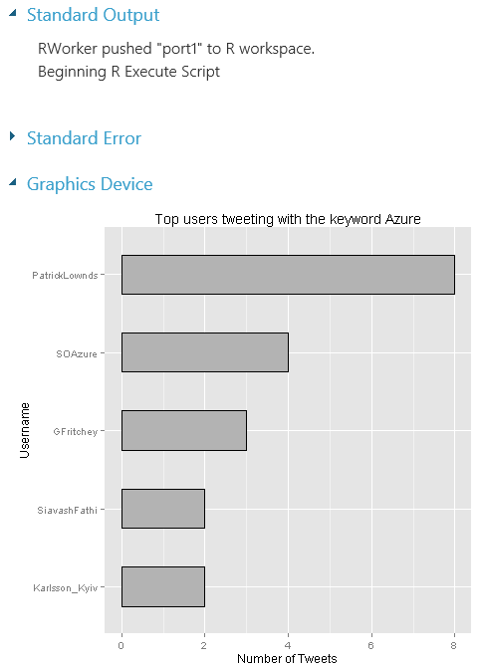

1. Click the X in the top right corner of the Visualize dialogue box to close it.

### Initial Tweet Preprocessing and Analysis

Next, you will do some term extraction and cleanup on the actual Tweets.

1. Make sure R Language Modules is expanded in the Modules pane



1. Click and drag the Execute R Script module onto the canvas under the Reader module and to the right of the other Execute R Script module.



1. Connect the output port from the Reader module to the first input port on the Execute R Script module.

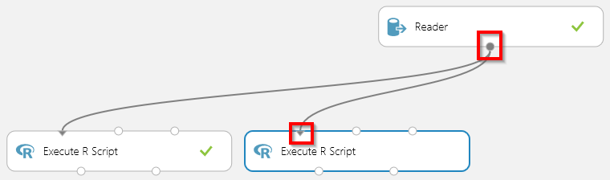

1. Click anywhere in the R Script editor to expand it.



1. Use the mouse to select all the code in the R Script editor and hit the Delete key on the keyboard.
2. Copy and paste the code below into the R Script editor:

library(dplyr)

library(tm)

library(SnowballC)

# set input data to object

Tweets<-as.data.frame(maml.mapInputPort(1))

# text pre-processing 1

myCorpus <- Corpus(VectorSource(Tweets$text))

myCorpus <- tm_map(myCorpus, stripWhitespace)

myCorpus <- tm_map(myCorpus, content_transformer(tolower))

myCorpus <- tm_map(myCorpus, removePunctuation)

# create matrix of terms with frequency of terms

tdm <- TermDocumentMatrix(myCorpus, control = list(wordLengths=c(1, Inf)))

m <- as.matrix(rowSums(as.matrix(tdm)),rownames.force=NA)

rownames(m) <- NULL

m <- data.frame(Terms=rownames(tdm), Frequency=m, stringsAsFactors = FALSE)

m <- arrange(m,desc(Frequency))

# output data

maml.mapOutputPort("m")

# visualize term frequency with wordcloud

library(wordcloud)

wordcloud(m[,1], m[,2], random.order = FALSE, random.color = FALSE, scale = c(10, .5), colors = c(colors(),"orange"))

1. Click RUN at the bottom of the canvas to execute the experiment with the R script.

This script uses only the Tweets column from the data in the left input port. It processes the Tweets by removing whitespace in words, transforming all the words to lowercase, and removing all the punctuation. Then it creates a dataset of the different terms in the Tweets and the number of occurrences (frequency) of each term. Finally, the term frequency is visualized in a word cloud.

1. Once the experiment has finished executing, click the left output port on the Execute R Script module and select Visualize from the displayed menu.



Notice the list of terms and their associated frequencies. There are some relevant terms like “Azure” and “cloud” near the top, but there are also a lot of terms like “a”, “to”, and “the” which do not offer much analytical value. As you scroll through the list, you will also encounter numbers like 1 and 50 in the terms list that also do not offer much analytical value at this point.

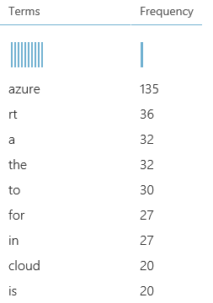

1. Click the X in the top right corner of the Visualize dialogue box to close it.
2. Click the right output port on the Execute R Script module and select Visualize from the displayed menu.



A word cloud is displayed in the Visualize dialogue box. Do not worry if your word cloud does not look exactly like the one shown below, as the R function that creates the word cloud randomly arranges the words each time it runs. In this word cloud, the size of the word represents its relative frequency compared with other words. Again, you will notice words like Azure and Microsoft are bigger, but you also see many words like “in”, “with” and “is” cluttering up the cloud.

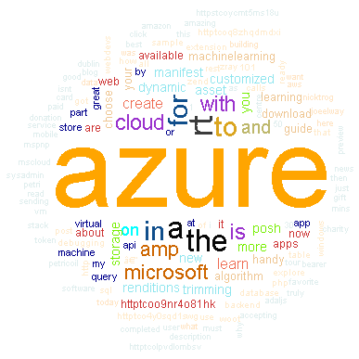

1. Click the X in the top right corner of the Visualize dialogue box to close it.

### Remove “Stop” Words and Numbers

Next, you will use an R Script that includes additional data prep tasks for removing some of the words and numbers that are less valuable for analytics.

1. Make sure R Language Modules is expanded in the Modules pane



1. Click and drag the Execute R Script module onto the canvas under the Reader module and to the right of the other Execute R Script modules.



1. Connect the output port from the Reader module to the first input port on the Execute R Script module.

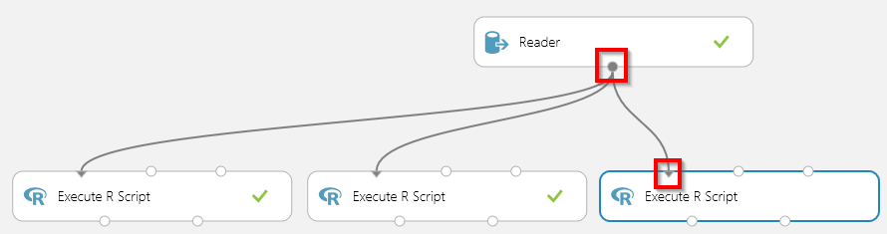

1. Click anywhere in the R Script editor to expand it.



1. Use the mouse to select all the code in the R Script editor and hit the Delete key on the keyboard.
2. Copy and paste the code below into the R Script editor:

library(dplyr)

library(tm)

library(SnowballC)

# set input data to object

Tweets<-as.data.frame(maml.mapInputPort(1))

# text pre-processing 1

myCorpus <- Corpus(VectorSource(Tweets$text))

myCorpus <- tm_map(myCorpus, stripWhitespace)

myCorpus <- tm_map(myCorpus, content_transformer(tolower))

myCorpus <- tm_map(myCorpus, removePunctuation)

# text pre-processing 2: remove numbers and stop words

myCorpus <- tm_map(myCorpus, removeNumbers)

myStopWords <- c(stopwords("english"))

myCorpus <- tm_map(myCorpus, removeWords, myStopWords)

# create matrix of terms with frequency of terms

tdm <- TermDocumentMatrix(myCorpus, control = list(wordLengths=c(1, Inf)))

m <- as.matrix(rowSums(as.matrix(tdm)),rownames.force=NA)

rownames(m) <- NULL

m <- data.frame(Terms=rownames(tdm), Frequency=m, stringsAsFactors = FALSE)

m <- arrange(m,desc(Frequency))

# output data

maml.mapOutputPort("m")

# visualize term frequency with wordcloud

library(wordcloud)

wordcloud(m[,1], m[,2], random.order = FALSE, random.color = FALSE, scale = c(10, .5), colors = c(colors(),"orange"))

1. Click RUN at the bottom of the canvas to execute the experiment.

This script builds on the previous script you used. It adds a series of processing steps for removing numbers and common words that are not relevant for analytics (typically called *stop words*).

1. Once the experiment has finished executing, click the left output port on the Execute R Script module and select Visualize from the displayed menu.



Notice the new list of words does not include the “stop” words (“a”, “the”, etc.) or the number terms.

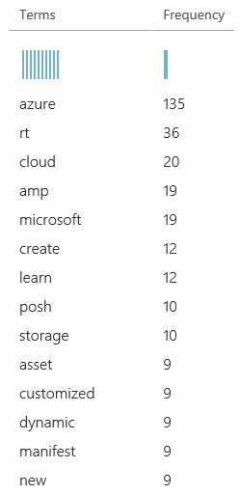

1. Scroll through the list and find the term “learn”.

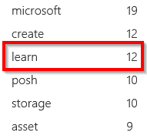

Notice it has 12 occurrences.

1. Scroll a little further down the list until you find “learning”.

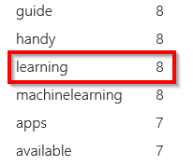

Notice it has 8 occurrences.

“Learn”, “Learned”, and “Learning” are all derivatives of the same word. Later, we might want to group all derivatives of the same word together and sum up their occurrences as a single term (resulting in 20 total occurrences of the base word “learn”).

1. Click the X in the top right corner of the Visualize dialogue box to close it.
2. Click the right output port on the Execute R Script module and select Visualize from the displayed menu.



Notice the new word cloud highlights many more relevant terms for analysis than the previous word cloud.

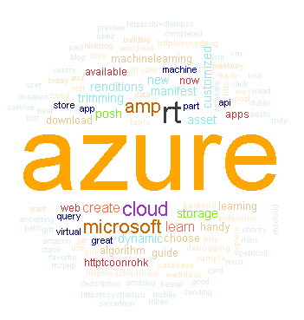

1. Click the X in the top right corner of the Visualize dialogue box to close it.

### Combine Words with Stemming

As we saw in the previous set of steps, there are instances of words we would like to combine so they are counted as 1 term. In this final set of steps, we will use a method called stemming to do this.

1. Make sure R Language Modules is expanded in the Modules pane



1. Click and drag the Execute R Script module onto the canvas under the Reader module and to the right of the other Execute R Script modules.



1. Connect the output port from the Reader module to the first input port on the Execute R Script module.

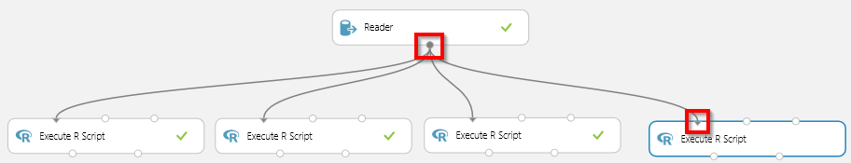

1. Click anywhere in the R Script editor to expand it.



1. Use the mouse to select all the code in the R Script editor and hit the Delete key on the keyboard.
2. Copy and paste the code below into the R Script editor:

library(dplyr)

library(tm)

library(SnowballC)

# set input data to object

Tweets<-as.data.frame(maml.mapInputPort(1))

# text pre-processing 1

myCorpus <- Corpus(VectorSource(Tweets$text))

myCorpus <- tm_map(myCorpus, stripWhitespace)

myCorpus <- tm_map(myCorpus, content_transformer(tolower))

myCorpus <- tm_map(myCorpus, removePunctuation)

# text pre-processing 2: remove numbers and stop words

myCorpus <- tm_map(myCorpus, removeNumbers)

myStopWords <- c(stopwords("english"))

myCorpus <- tm_map(myCorpus, removeWords, myStopWords)

# text pre-processing 3: stem words

myCorpusCopy <- myCorpus

myCorpus <- tm_map(myCorpus, stemDocument)

# convert stems to real words

stemCompletion2 <- function(x, dictionary) {

x <- unlist(strsplit(as.character(x), " "))

x <- x[x != ""]

x <- stemCompletion(x, dictionary = dictionary)

x <- paste(x, sep="", collapse=" ")

PlainTextDocument(stripWhitespace(x))

}

myCorpus2 <- lapply(myCorpus, stemCompletion2, dictionary=myCorpusCopy)

myCorpus <- Corpus(VectorSource(myCorpus2))

# create matrix of terms with frequency of terms

tdm <- TermDocumentMatrix(myCorpus, control = list(wordLengths=c(1, Inf)))

m <- as.matrix(rowSums(as.matrix(tdm)),rownames.force=NA)

rownames(m) <- NULL

m <- data.frame(Terms=rownames(tdm), Frequency=m, stringsAsFactors = FALSE)

m <- arrange(m,desc(Frequency))

# output data

maml.mapOutputPort("m")

# visualize term frequency with wordcloud

library(wordcloud)

wordcloud(m[,1], m[,2], random.order = FALSE, random.color = FALSE, scale = c(10, .5), colors = c(colors(),"orange"))

1. Click RUN at the bottom of the canvas to execute the experiment.

This code builds on the previous scripts, but it also includes steps for stemming words. Stemming is the process of breaking a word down to its root, and then combining it with other words that resulted in the same root.

As an example, the words “like”, “liked”, “likes”, and “liking” would all be stemmed to “lik”. After being stemmed and combined, the stem word “lik” would usually be transformed back to the root word. In this example, the root word would be “like”. This process would result in all derivatives of “like” (like, liked, likes, and liking) being counted as a single term.

1. Once the experiment has finished executing, click the left output port on the Execute R Script module and select Visualize from the displayed menu.



Notice the term “learn” is now a top 4 term with 20 occurrences (the sum of the original “learn” and “learning”).

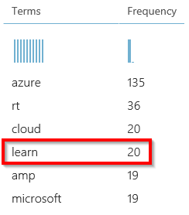

1. Click the X in the top right corner of the Visualize dialogue box to close it.
2. Click the right output port on the Execute R Script module and select Visualize from the displayed menu.



Notice the term “learn” is more dominant than in previous word clouds.

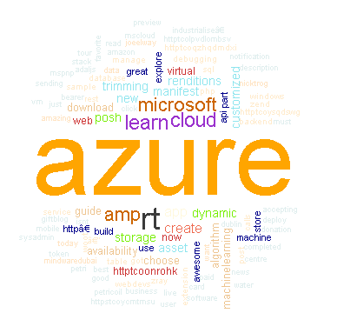

1. Click the X in the top right corner of the Visualize dialogue box to close it.
2. Sign out of your workspace by clicking the profile picture at the top right of the page and selecting Sign Out from the displayed menu.

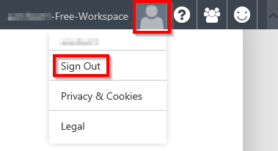

### Conclusion

This concludes the *Text Analytics with R and Azure Machine Learning* lab. In this lab, you loaded data from an external source, executed R scripts in ML Studio, and performed common text analytics tasks and visualizations.

The methods and scripts used in this lab can be extended further to find Tweets with specific terms, related products or ideas, or even related websites and blog posts.

|  |
| --- |
| Terms of Use |

© 2015 Microsoft Corporation. All rights reserved.

By using this Hands-on Lab, you agree to the following terms:

The technology/functionality described in this Hands-on Lab is provided by Microsoft Corporation in a “sandbox” testing environment for purposes of obtaining your feedback and to provide you with a learning experience. You may only use the Hands-on Lab to evaluate such technology features and functionality and provide feedback to Microsoft.  You may not use it for any other purpose. You may not modify, copy, distribute, transmit, display, perform, reproduce, publish, license, create derivative works from, transfer, or sell this Hands-on Lab or any portion thereof.

COPYING OR REPRODUCTION OF THE HANDS-ON LAB (OR ANY PORTION OF IT) TO ANY OTHER SERVER OR LOCATION FOR FURTHER REPRODUCTION OR REDISTRIBUTION IS EXPRESSLY PROHIBITED.

THIS HANDS-ON LAB PROVIDES CERTAIN SOFTWARE TECHNOLOGY/PRODUCT FEATURES AND FUNCTIONALITY, INCLUDING POTENTIAL NEW FEATURES AND CONCEPTS, IN A SIMULATED ENVIRONMENT WITHOUT COMPLEX SET-UP OR INSTALLATION FOR THE PURPOSE DESCRIBED ABOVE.  THE TECHNOLOGY/CONCEPTS REPRESENTED IN THIS HANDS-ON LAB MAY NOT REPRESENT FULL FEATURE FUNCTIONALITY AND MAY NOT WORK THE WAY A FINAL VERSION MAY WORK.  WE ALSO MAY NOT RELEASE A FINAL VERSION OF SUCH FEATURES OR CONCEPTS.  YOUR EXPERIENCE WITH USING SUCH FEATURES AND FUNCITONALITY IN A PHYSICAL ENVIRONMENT MAY ALSO BE DIFFERENT.

**FEEDBACK**.  If you give feedback about the technology features, functionality and/or concepts described in this Hands-on Lab to Microsoft, you give to Microsoft, without charge, the right to use, share and commercialize your feedback in any way and for any purpose.  You also give to third parties, without charge, any patent rights needed for their products, technologies and services to use or interface with any specific parts of a Microsoft software or service that includes the feedback.  You will not give feedback that is subject to a license that requires Microsoft to license its software or documentation to third parties because we include your feedback in them.  These rights survive this agreement.

MICROSOFT CORPORATION HEREBY DISCLAIMS ALL WARRANTIES AND CONDITIONS WITH REGARD TO THE HANDS-ON LAB , INCLUDING ALL WARRANTIES AND CONDITIONS OF MERCHANTABILITY, WHETHER EXPRESS, IMPLIED OR STATUTORY, FITNESS FOR A PARTICULAR PURPOSE, TITLE AND NON-INFRINGEMENT.  MICROSOFT DOES NOT MAKE ANY ASSURANCES OR REPRESENTATIONS WITH REGARD TO THE ACCURACY OF THE RESULTS, OUTPUT THAT DERIVES FROM USE OF THE VIRTUAL LAB, OR SUITABILITY OF THE INFORMATION CONTAINED IN THE VIRTUAL LAB FOR ANY PURPOSE.

DISCLAIMER

This lab contains only a portion of the features and enhancements in Microsoft Azure Machine Learning. Some of the features might change in future releases of the product.